Exercise 6 : Implementation of React Router for Navigation in a React Application

Aim : To develop a React application using React Router that displays a list of trainers and their details using URL routing.

Objectives
- Explain the need and benefits of React Router.
- Identify the components in React Router.
- List the types of Router Components.
- Understand parameter passing through URLs.
- Implement a simple navigation menu.
- Configure routing in React.
- Retrieve URL parameters using useParams.

Prerequisites
- Node.js
- NPM
- Visual Studio Code
- React
- React Router DOM

Procedure
Step 1 Create a React application.
npx create-react-app trainersapp
Step 2 Move into the project folder.
cd trainersapp
Step 3 Install React Router.
npm install react-router-dom
Step 4 Create the following files.
trainer.js
TrainersMock.js
Home.js
TrainersList.js
TrainerDetails.js
Step 5 Define the Trainer class.
Step 6 Create mock trainer data inside TrainersMock.js.
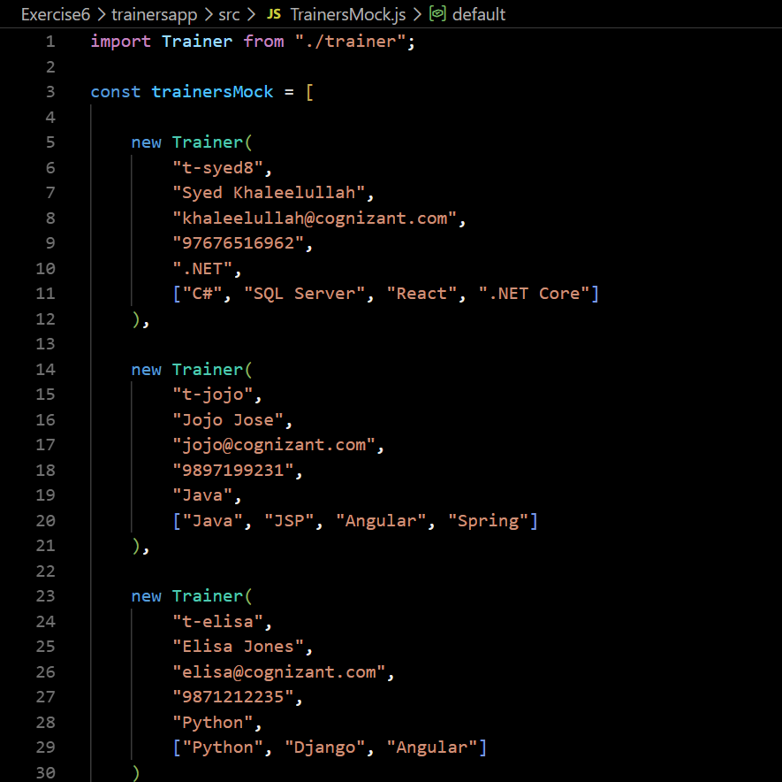
Step 7 Create the Home component.
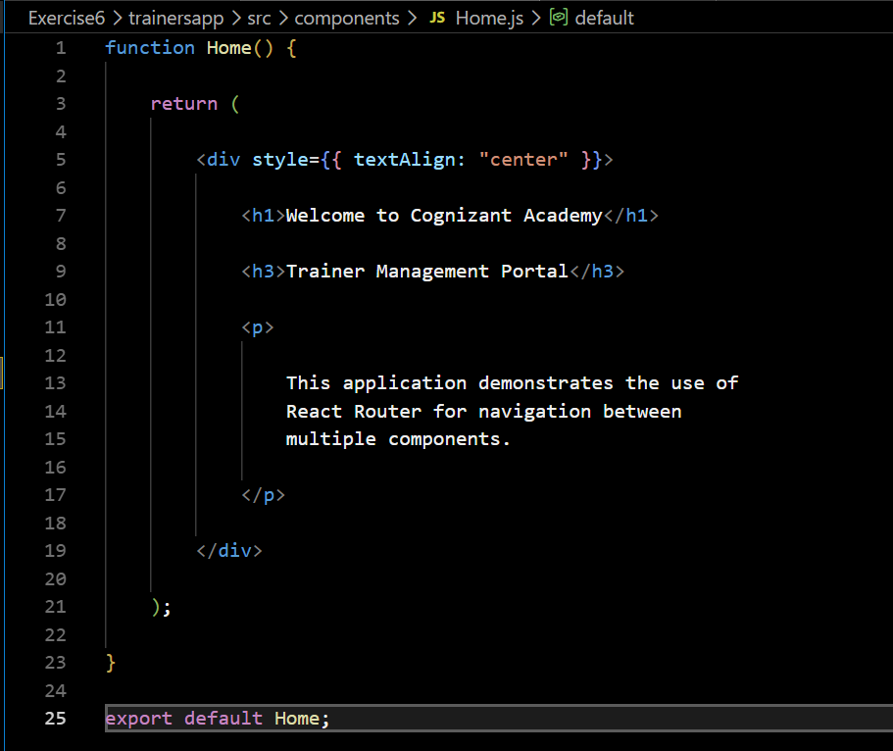

Step 8 Create the Trainers List component.
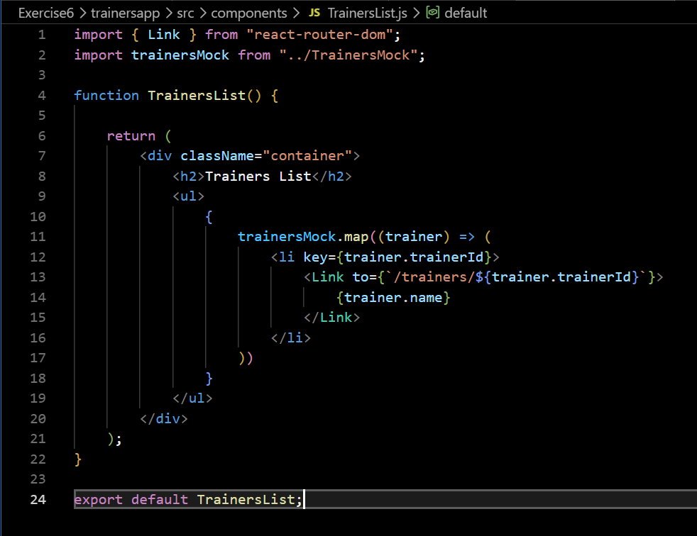

Step 9 Create the Trainer Details component.
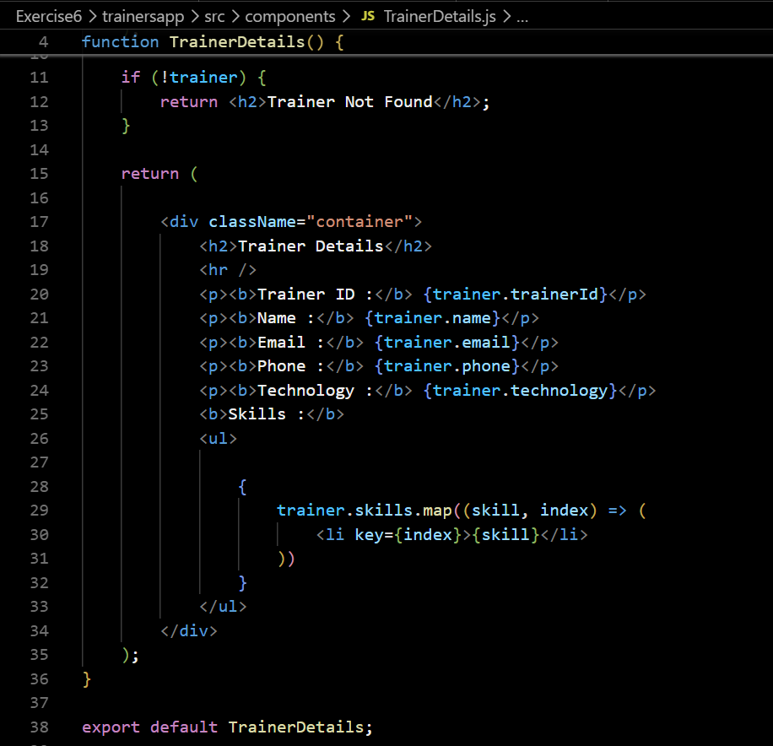
Step 10 Configure routing using
- BrowserRouter
- Routes
- Route
- Link
- useParams
Step 11 Run the application.
npm start

Output :
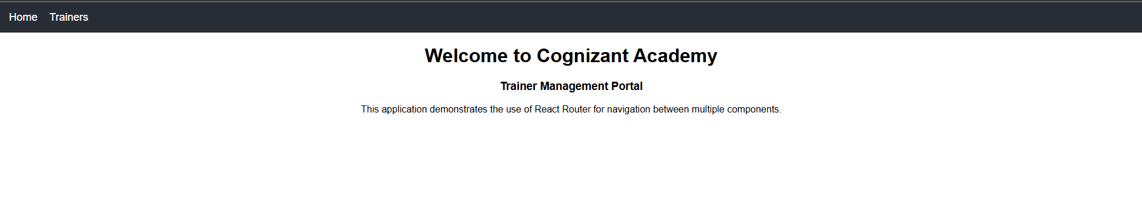
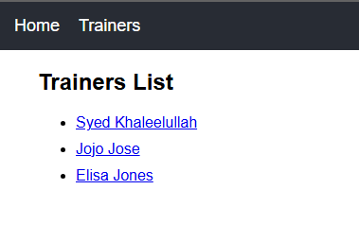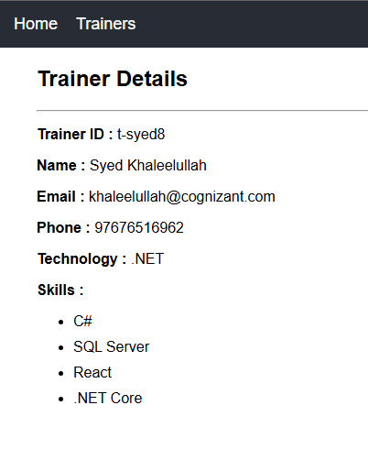

Result :
The React application was successfully developed using React Router. Navigation between the Home page, Trainers List page, and Trainer Details page was implemented using BrowserRouter, Routes, Route, Link, and useParams. Trainer information was displayed dynamically based on the URL parameter. Thus, routing in React applications was implemented successfully.

